Blender model tutorial

Start with a cube and translate the vertices to reach this shape

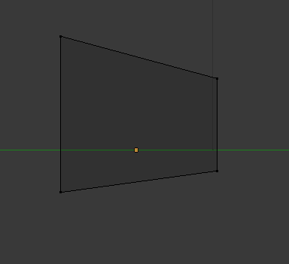

Extrude the left face about 3 units and translate the vertices downwards by 2 units

Now scale the face down and rotate to face downwards, you should have this

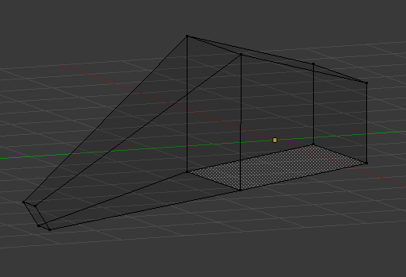

This will be the nose of our spaceship

Now select the right face of the object and extrude by 2.5 units then scale down the face

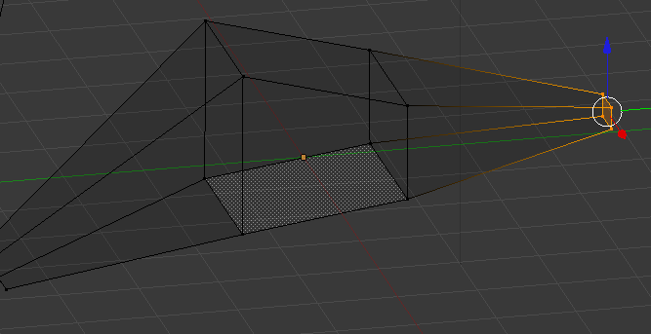

This will be our tail end of the spaceship

Now switch to top view with num 7 and scale in the middle portion to make the body thinnger

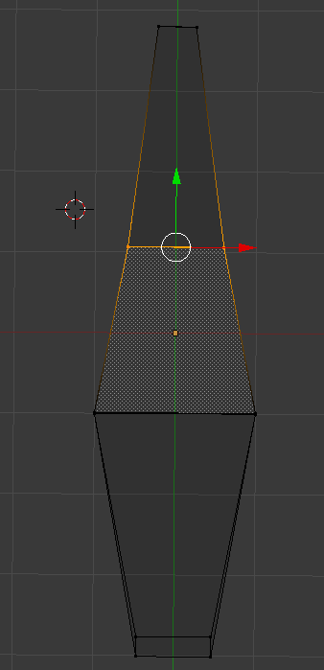

Use the loop and cut slide tool to create edges about a third of the distance from the middle block

Then switch to top view and widen. Do this once more nearer to the nose.

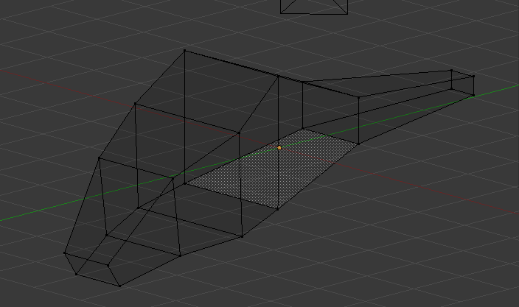

Use the loop and cut tool on the tail end to make it taper towards the end and give it a more organic look. You can add more loops and make the shape more details like I have on the next image but it is not too important. What we really need is a basic shape that will be the base of the spaceship model.

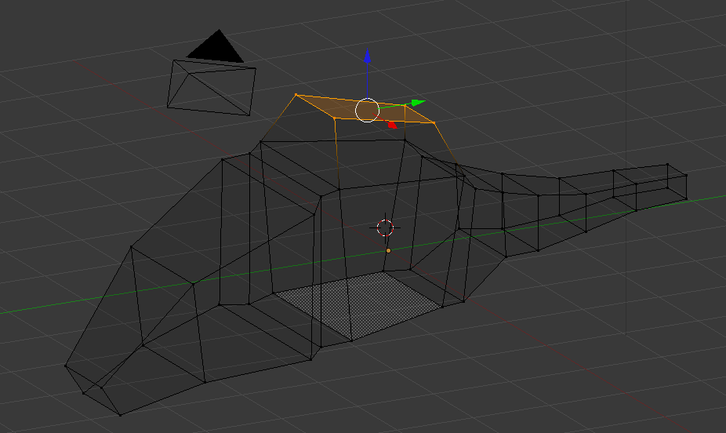

Add a loop down the middle 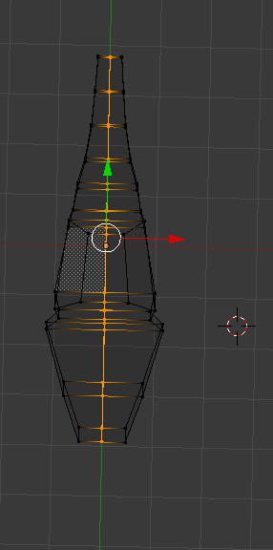

And select the left side of the object

Then delete the faces, you should have this.

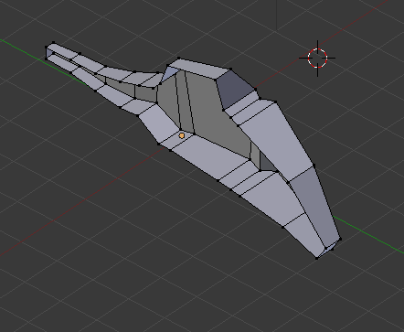

now move cursor to selected and add a mirror modifier

and the model will be whole again. In the settings for the moedifier make sure clipping is enabled and that the mirror is on the x axis

how start extruding from the middle top cube to bring out the wings

noteice you only need to change the right side and the left will mirror the right.

Extrude and change the shape of the wings to how you want it. Try to get a curve in there.

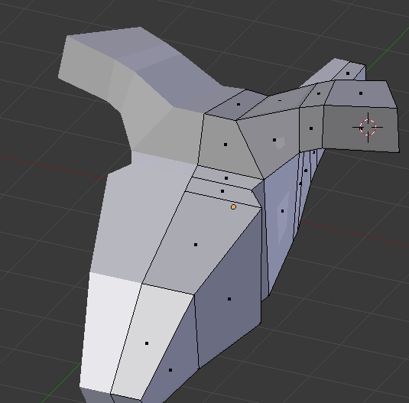

Next we will add a circle to modle the fans

Create a circle and set the vertices to 12

Scale the circle to the right size to match the wings and then extrude inwards

Then extrude down to give It thickness

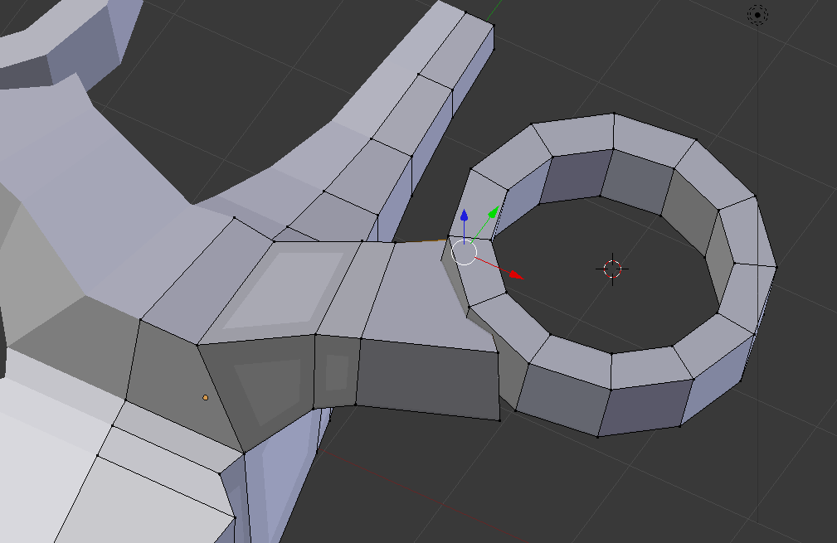

Now to match the wings to the circle

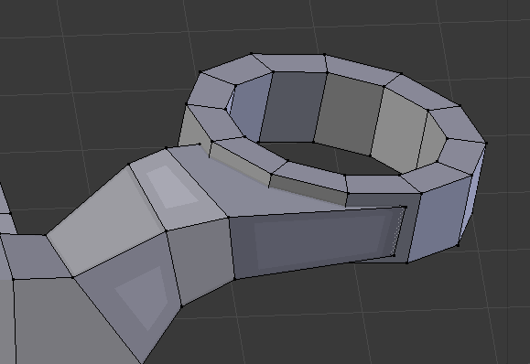

Now to add the tail fins

Go to the top view num7 and add a cube near the tail end

And translate the vertexes to resemble a tail fin shape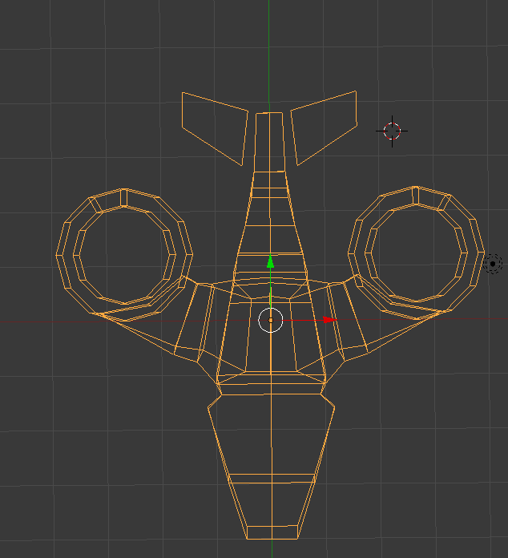

Scale the cube so that it is flatter and then extrude to connect to the body

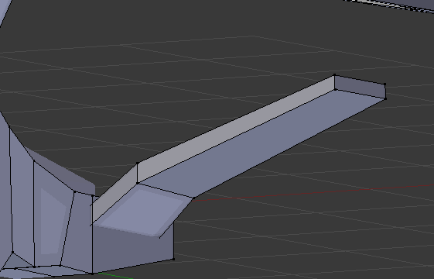

Next up we’re going to add two loop cuts along the side

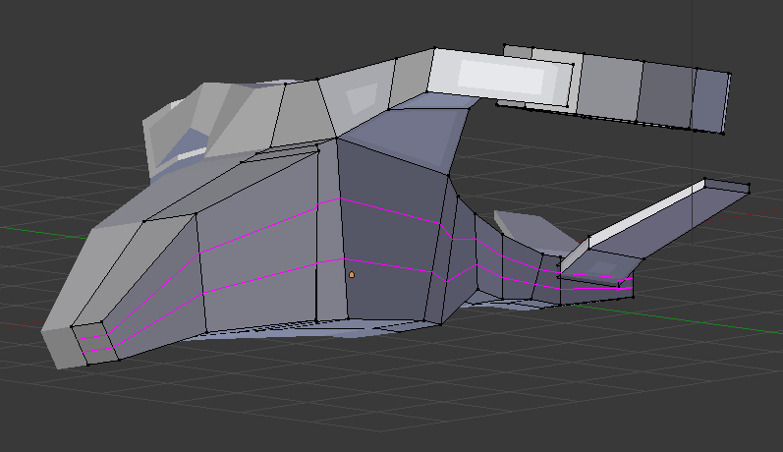

Now select the top vertices and use GX to bring them in closer and give the nose of the ship a more rounded look.

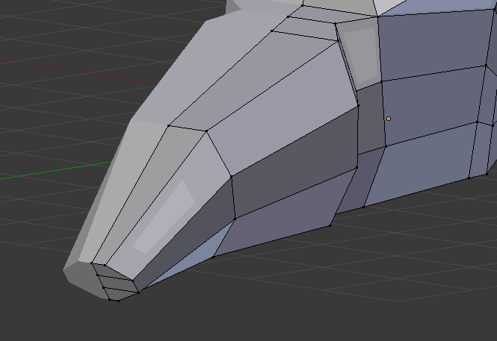

Do the same with the bottom vertices

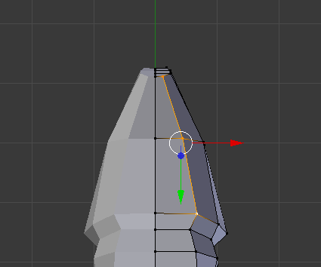

And the same with the tail end

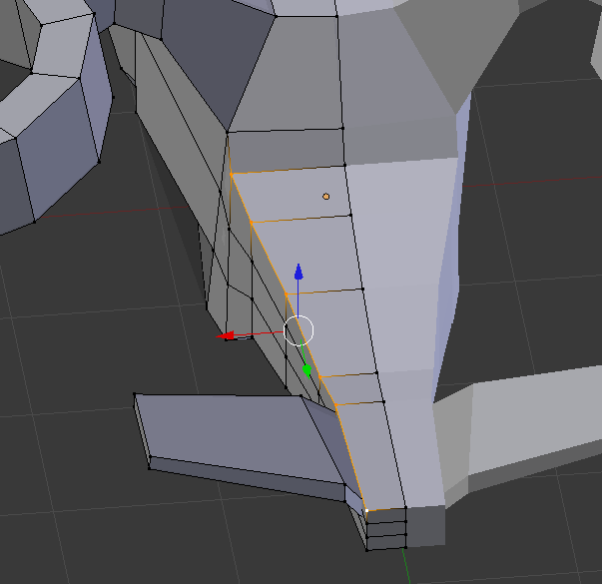

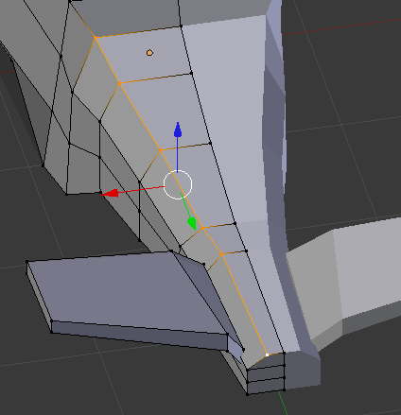

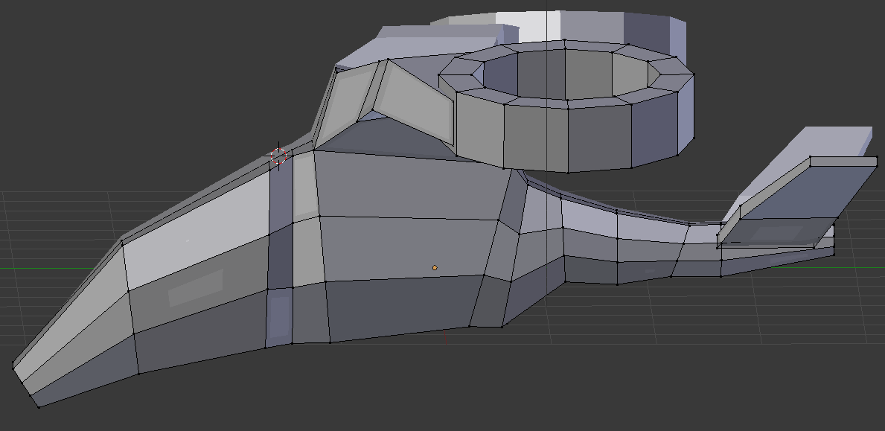Once done it should like the above

Now switch to front view num1 and roate to side with ctrl alt scroll

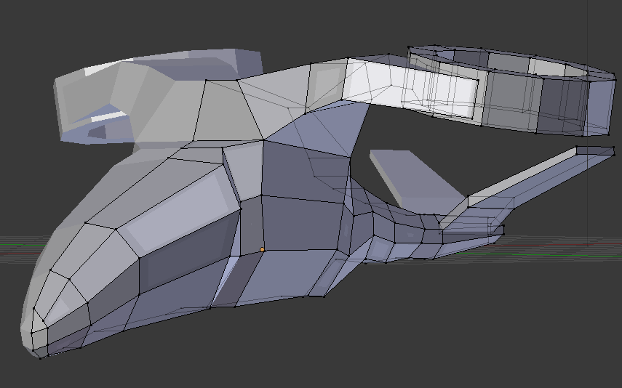we are going to make the wing area join the nose in a smoother fashion

Select this area of the model

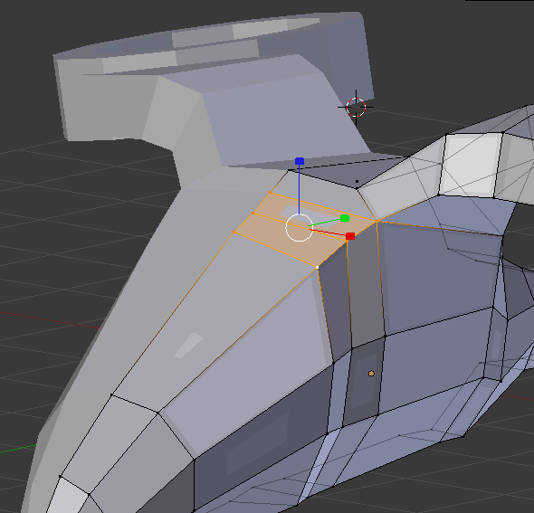

And raise it to reduce the hump on the wings

Also use GZ to bring the hump of the wings down a little

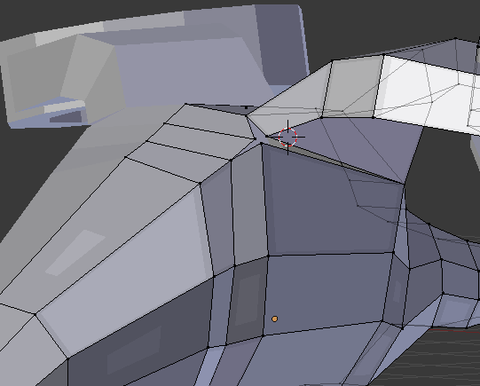next we are going to split this section up with the V key

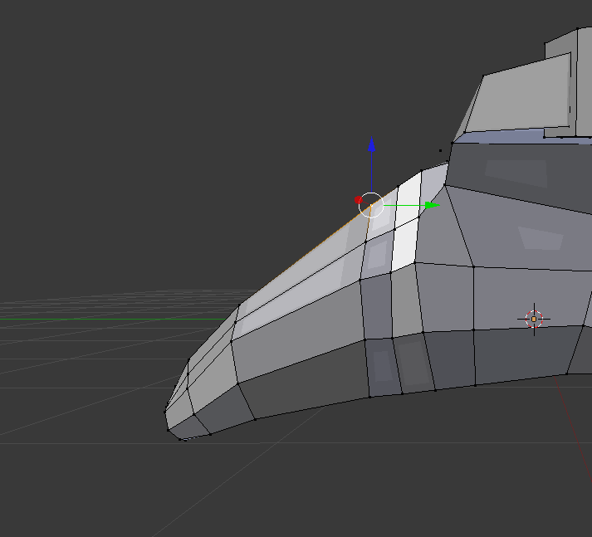 here we are going to improve the mesh flow by evening out the edges and vertices

Select the edges going down the vehicle and use edge slide to move it across

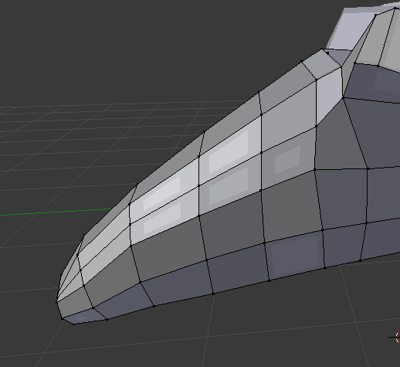like so

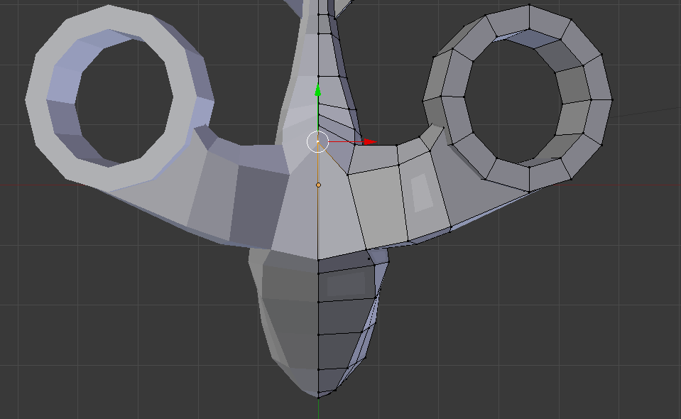Next we are going to adjust the top of the vehicle a bit. By bringing the middle vertex down and back

Next we are going to lower the wing slightly

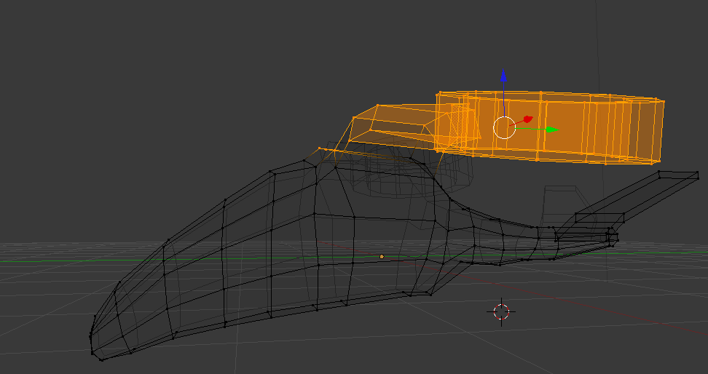 select the just the wing with **B** and hit O and lower the wing with g then z

Now we are going to separate the mesh into different sections, for the windscreen, engine area, tail fin

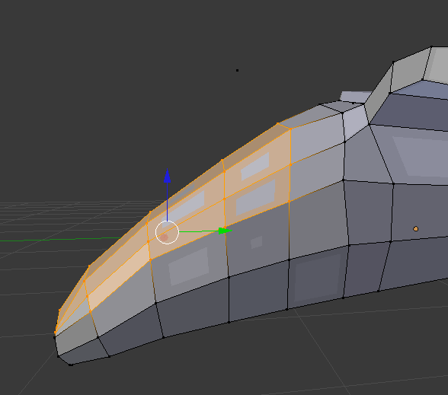Use ctrl left click to use the laso tool to select the wind screen area, now hit p then selection to separate by selection

Do the same for the tail fins

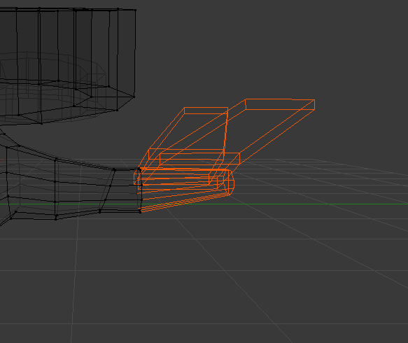

Next select the wings

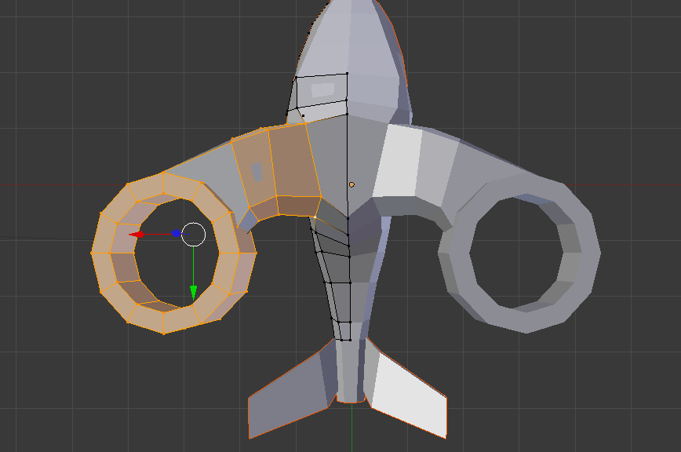

Select this area for the engine area

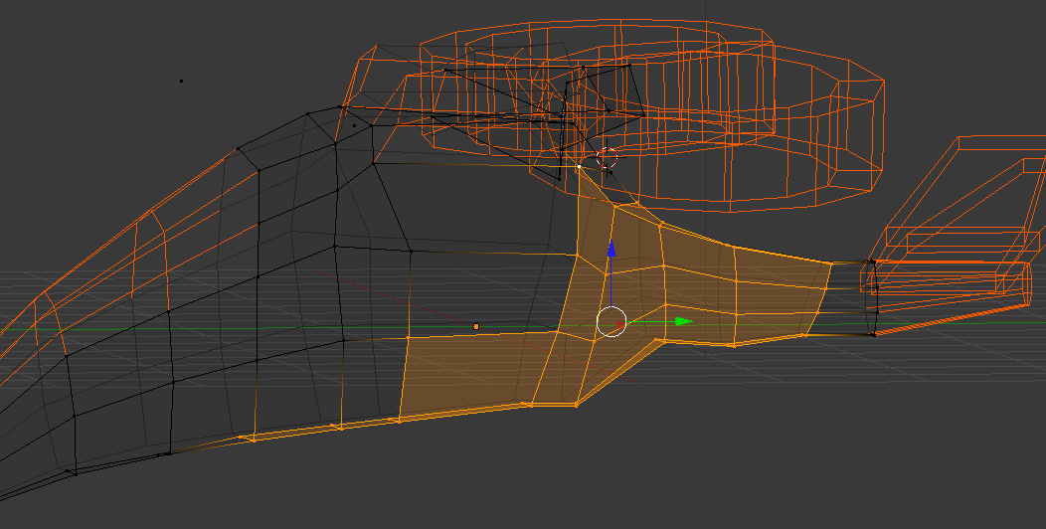

I also recommend you name each section 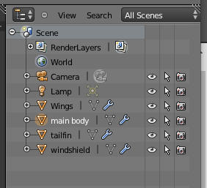

Now time to add some colour

Select the main body and go to the material section and give it a colour, for mine, I’ve given It a light blue colour. And a different colour for the windscreen

Next select the underside of the vehicle and go to materials and give this section a black colour or dark grey

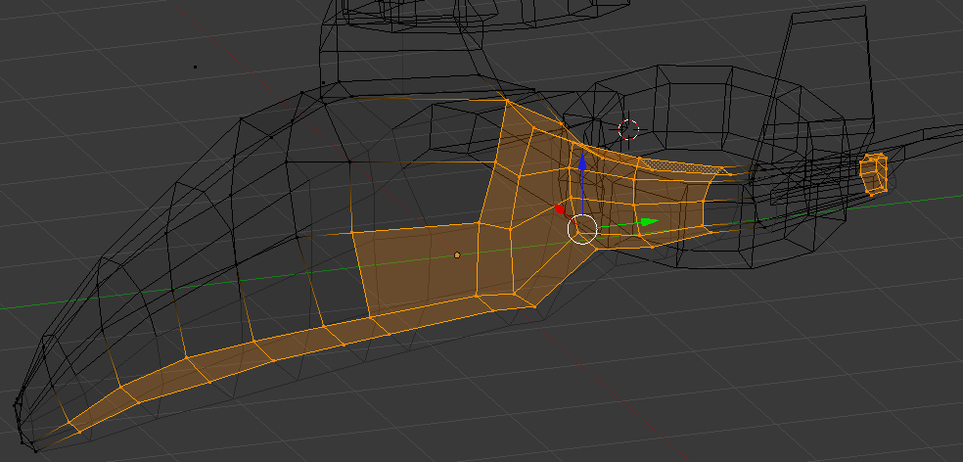

Like so 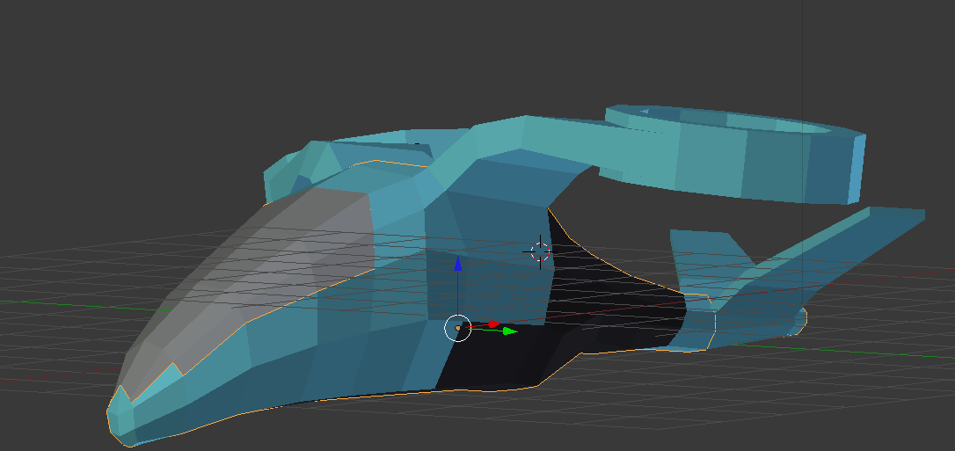

We are going to add detail to the windshield

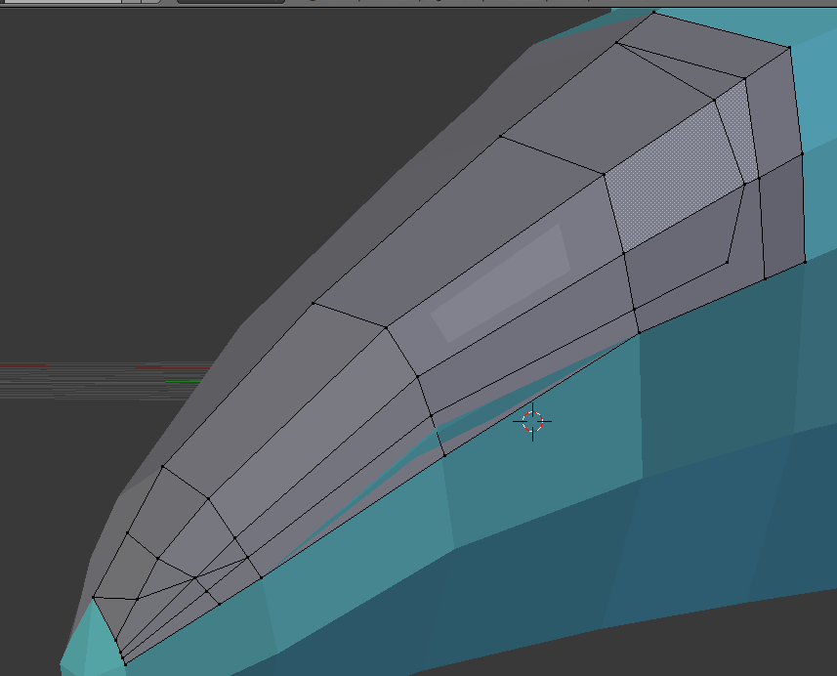create a oval shape in the windshield by creating vertexes using subdivide then connectin ghte vertexes with f key

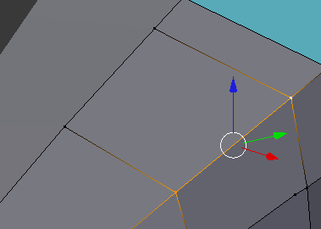select two vertices then open special menu and do subdivide

Now click the new vertex and the vertex you wish to connect and clikc f 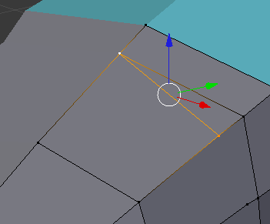 continue this until you have an oval shape

We have a problem 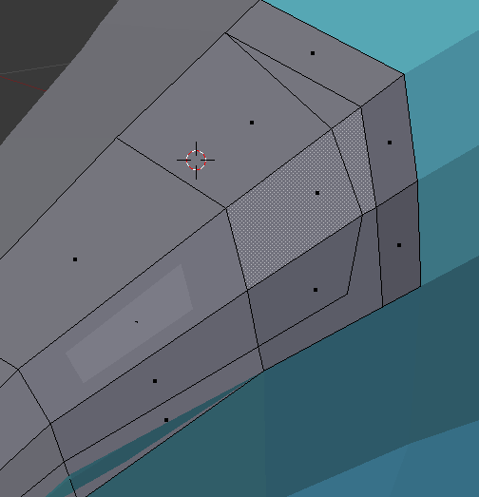

Our oval area doesn’t have it’s own faces so we will create them

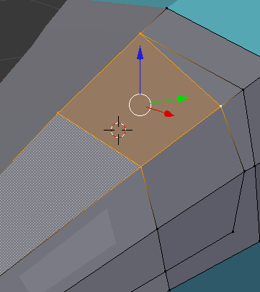 select the 4 points and click f, it will cfreate a face

Switch to face select and you should see and extra dot indicating an additional face

Do this for the rest fo the faces around the oval edge

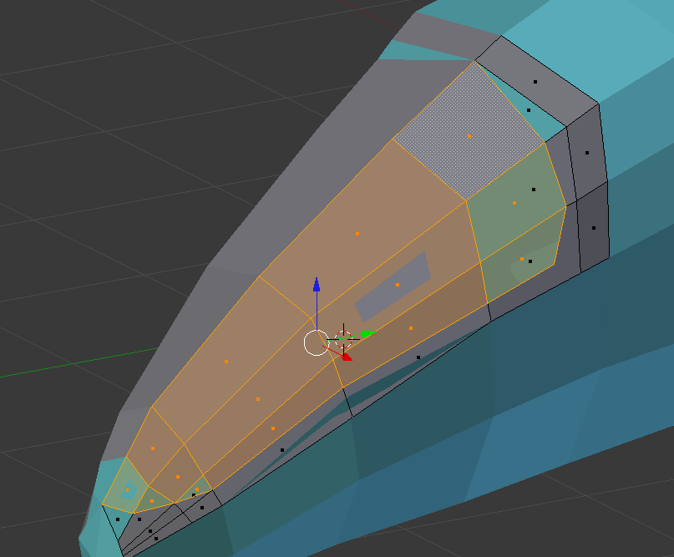like so , you will also notice I have some blue sections, simple select those and change the colour back

Select the oval area and extrude in x axis by -0.05 then select the whole windshield and remove doubles

Now extrude in z axis by -0.05

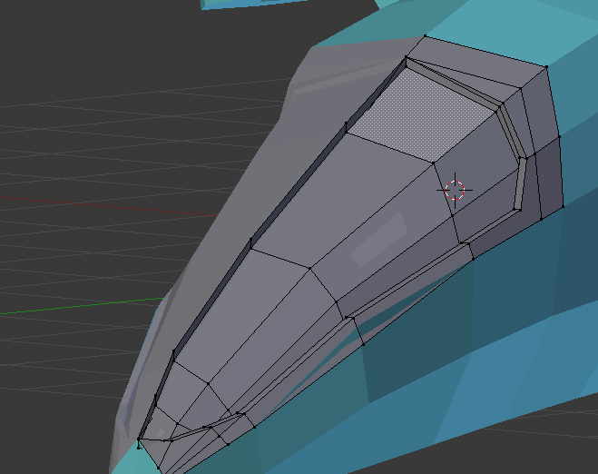now delete the edges in the midlle

You should have this 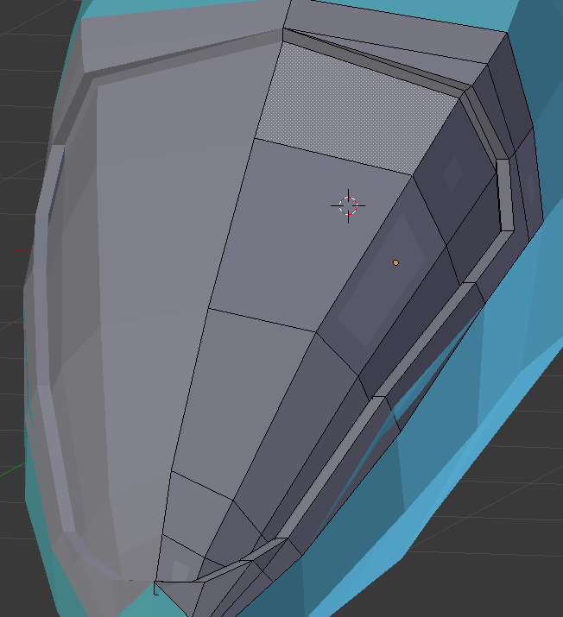

Notice this section 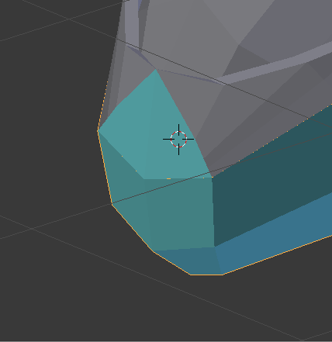 should be part of the windshield, so we will separate it from the main body

Then select it and the windshield and use ctrl + j to join it to the windshield

Then change the colour

Next change the colour of the windshield to a yellowish colour by adding a new material in the meterials panel and assigning it to the windshield area.

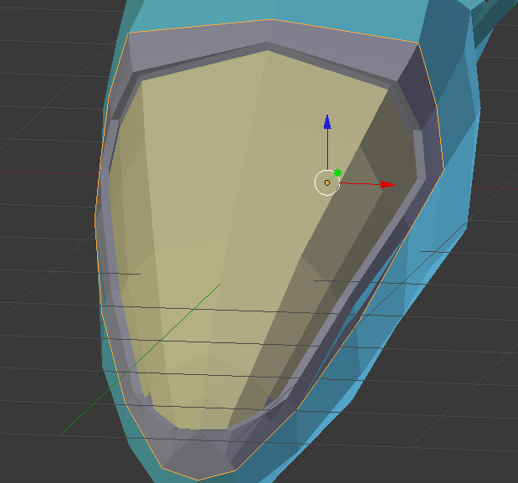

We are now going add some detailing to the body. Select these vertices

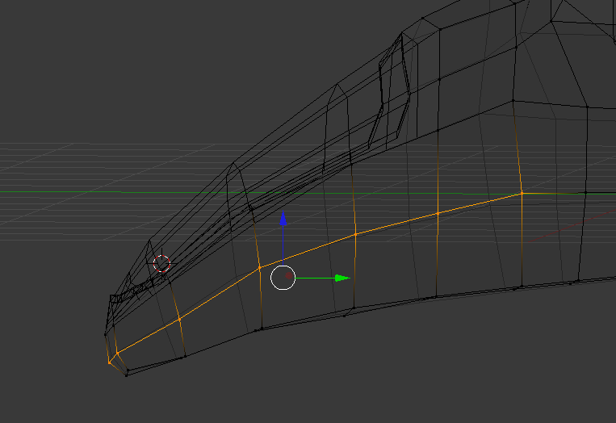

Aim for this kind of shape 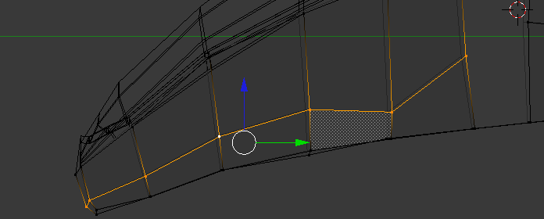

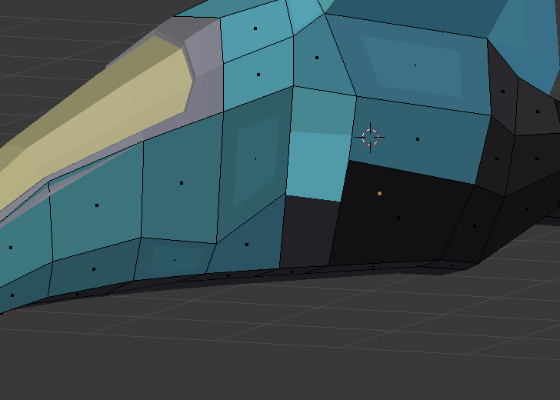delete these two faces for the time being

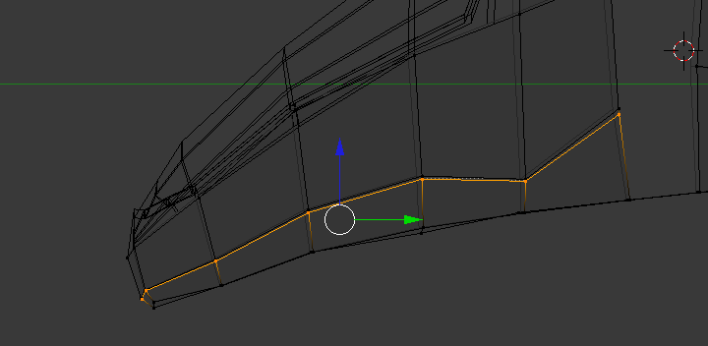

Create a loop cut near the line you bent earlier

And use g x to move it inwards a little then use s y to scale it in a little (by 1)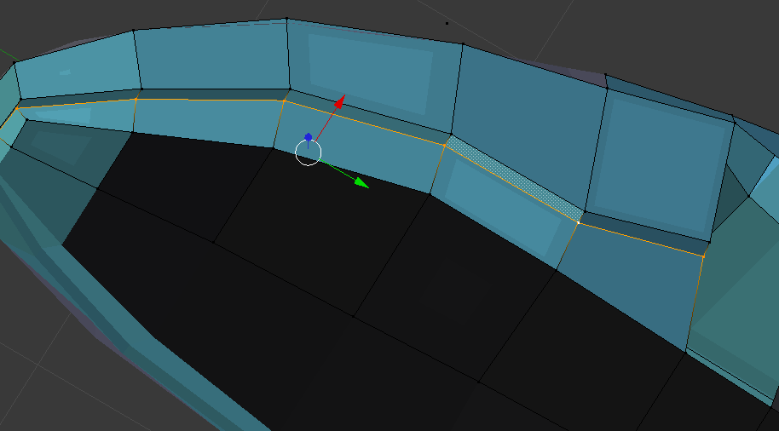

Now bring in the nose tip a little

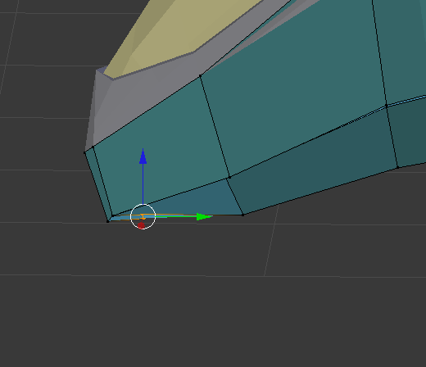

Change the coloru of the underside to dark grey 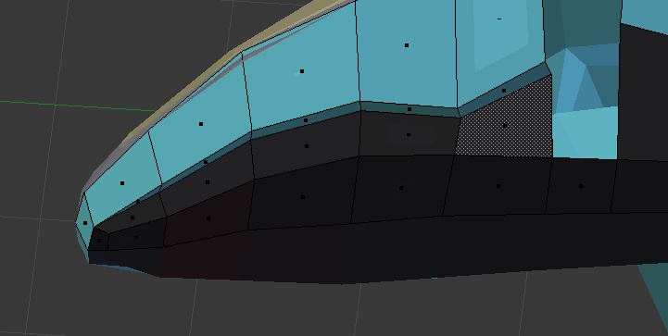

Add two loop cuts

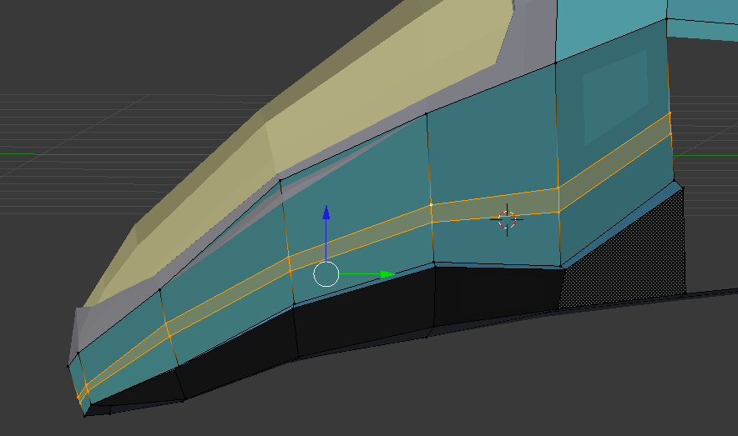

Select the bottom loop cut you created and translate it in the x axis by a small amount

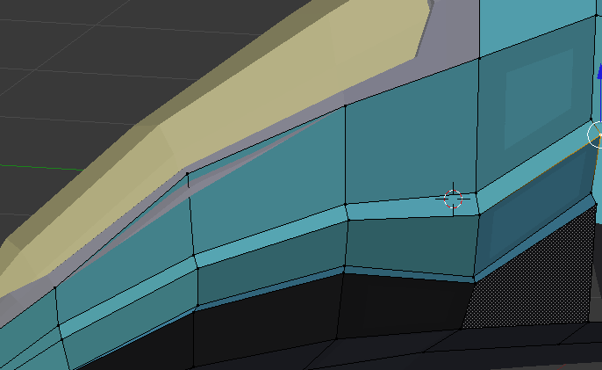

Do the same technique above again

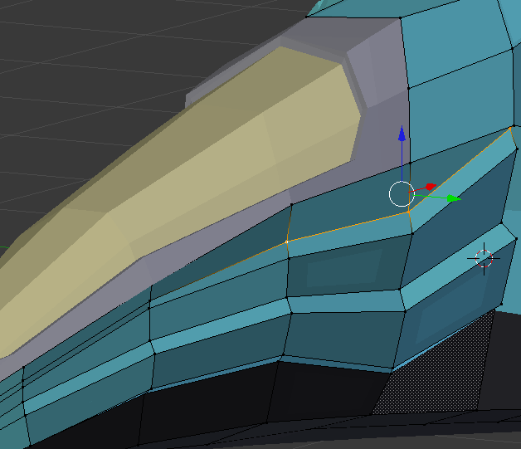

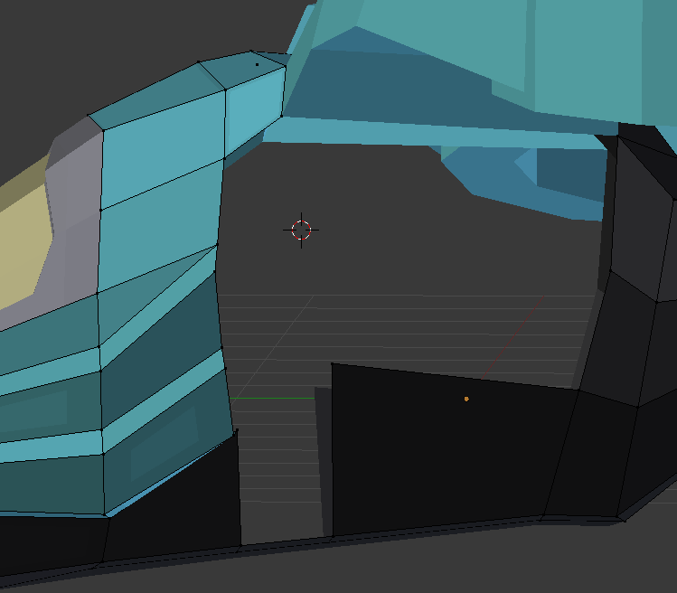delete these faces as we are going to extrude the body detailing in that area

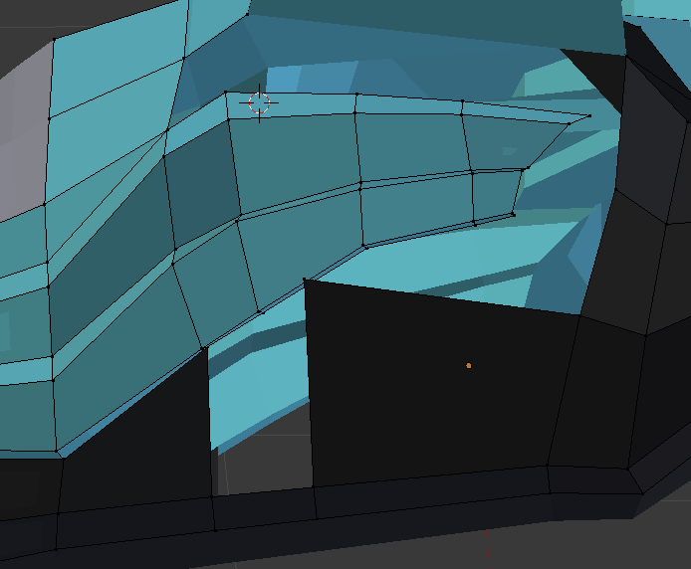

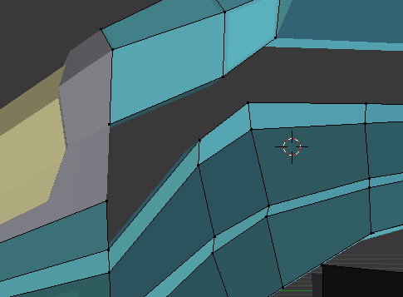 now delete this part 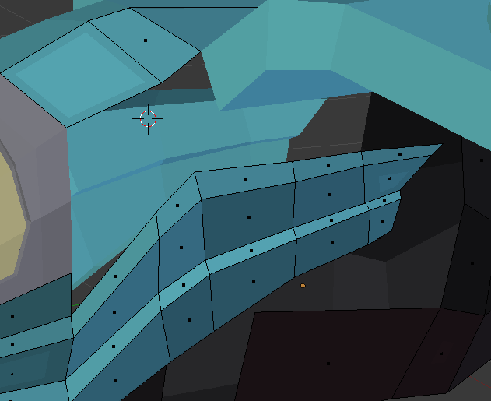

Go to top view select top two panels and disconnect them using y

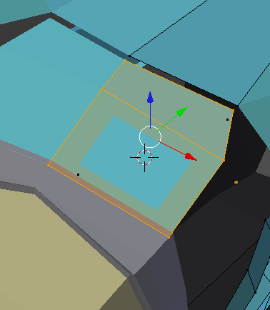

Make the panel smaller by using g on the x axis then add a loop going across and place the edges an even distance apart

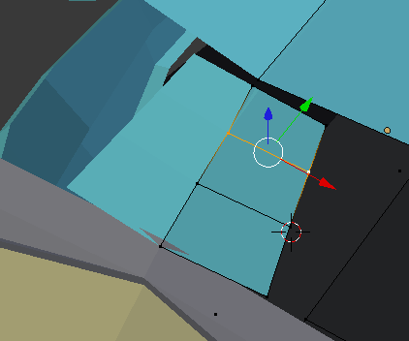

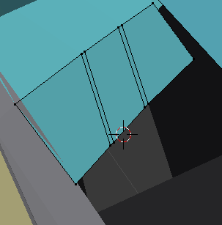

Add two more loops and select them both, then translate them on x axis a small amount

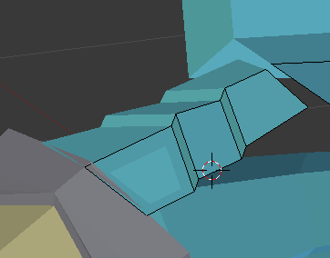

Next reconnect it to the spaceship

Now create a new cube

Scale it down using s and z and align it to fit in the empty space

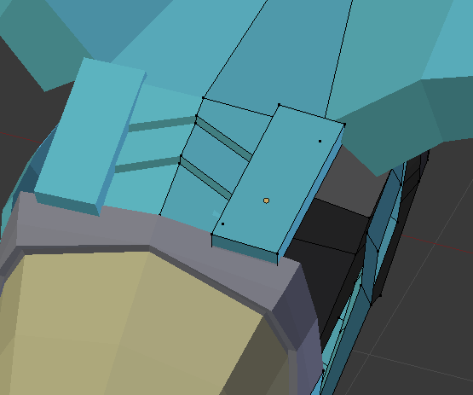

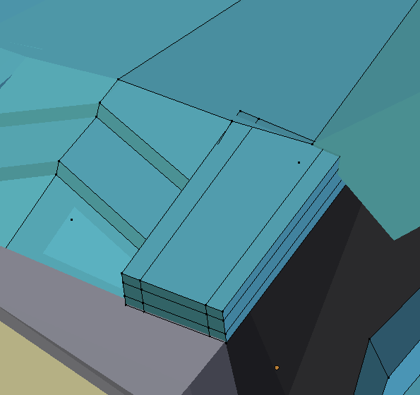

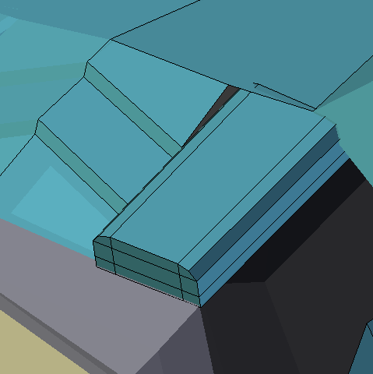

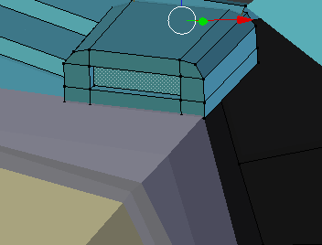

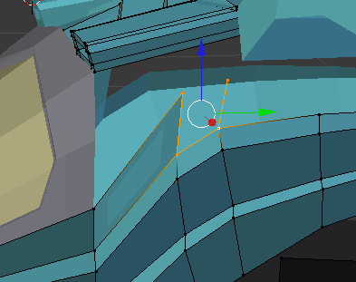

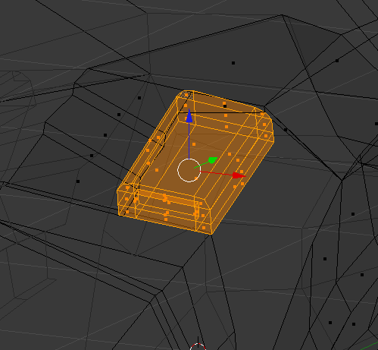

Select the cube we made earlier

And duplicate it

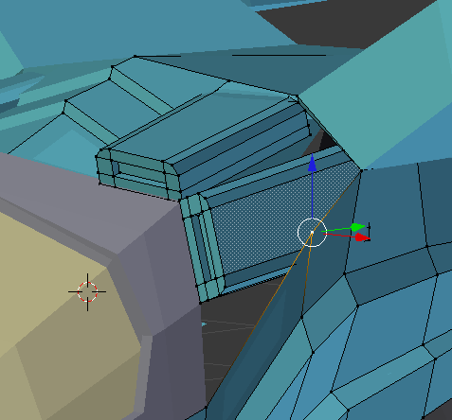 and place it in the empty space we have

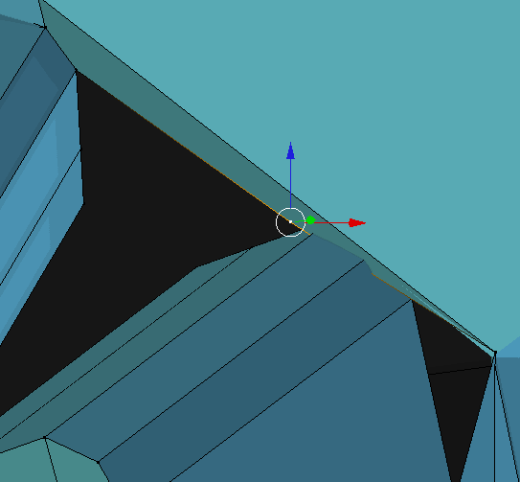subdivide this top line to create a certex and use it to create a face to cover up the empty space

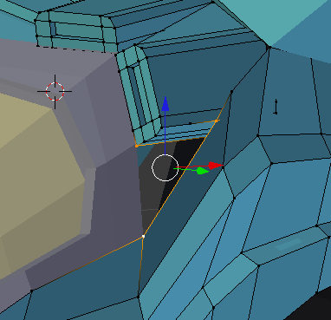 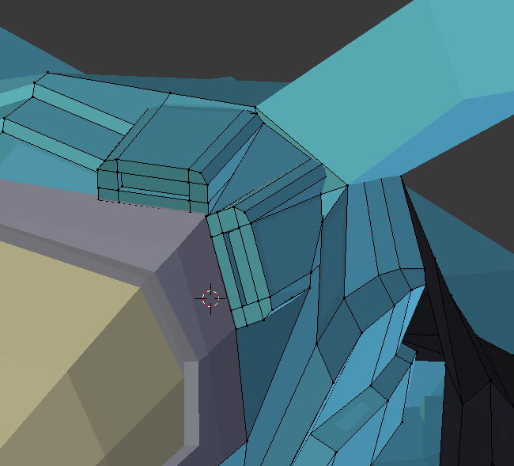

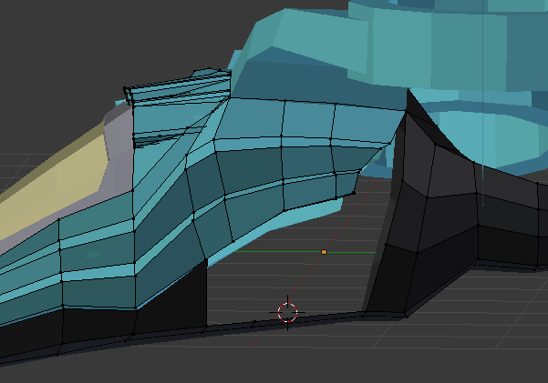

Now add the wheel we created earlier.

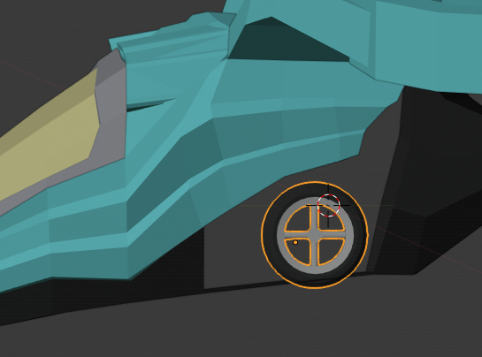rotate it so it’s right way up and scale it down to fit in the vehicle underside. I scaled down by 0.3

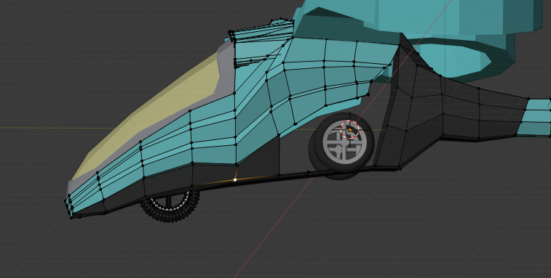add a mirror modifier and to the wheel with the main body as the mirror. And duplicate a wheel for the front

Now lower the wheels

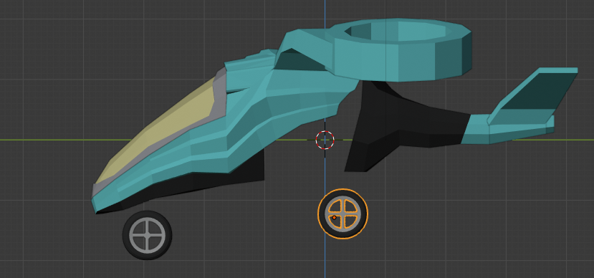 this is how the plane will look when it is landed

We will next add the pistons that will retract the wheels when in flight.

Create a cube and scale it down to 0.2 for z and y. then add two loops along the long side

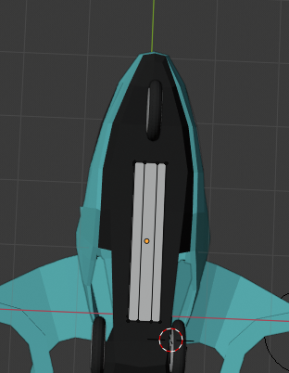

Align your piston with your wheel

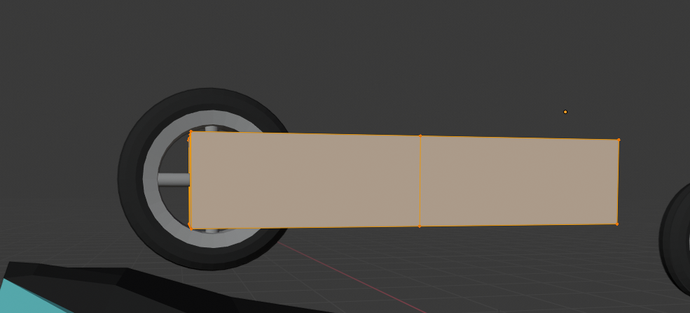

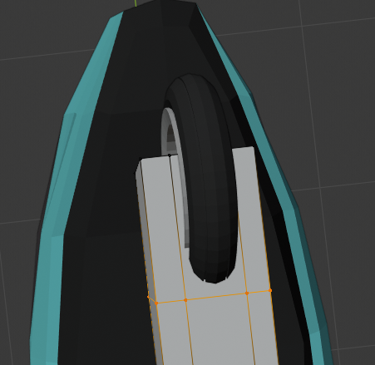 now delete the faces that are obstructing the wheel

Next select the sides of the piston and scale them inwards to give the piston a wrench like shape 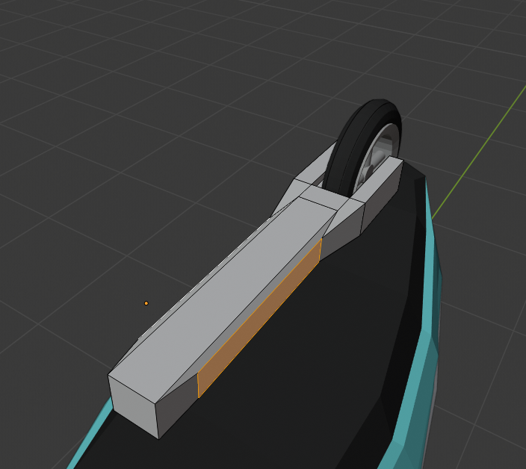

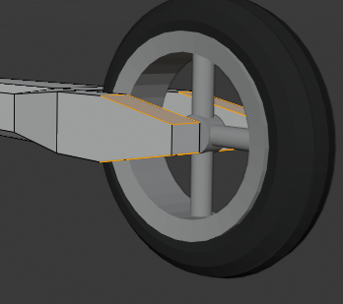 now select the edges near the wheel and use ctrl B to bevel them .

Now create a cylinder and rotate in y by 90 then scale down to 0.1

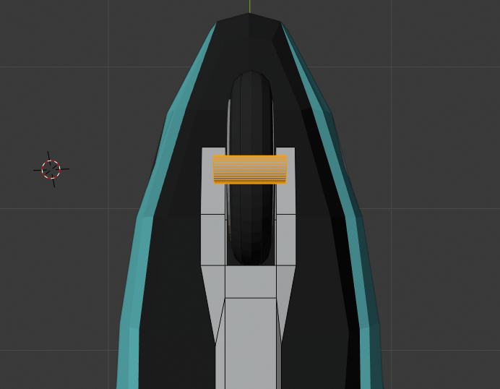

Expand in x direction by 1.3 and make smaller in z and y by 0.5

Now move the cylinder in place of the axle

Next up we need to fill these faces, disable the front wheel to see these easier

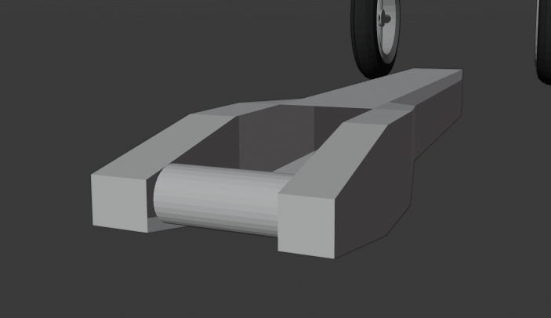

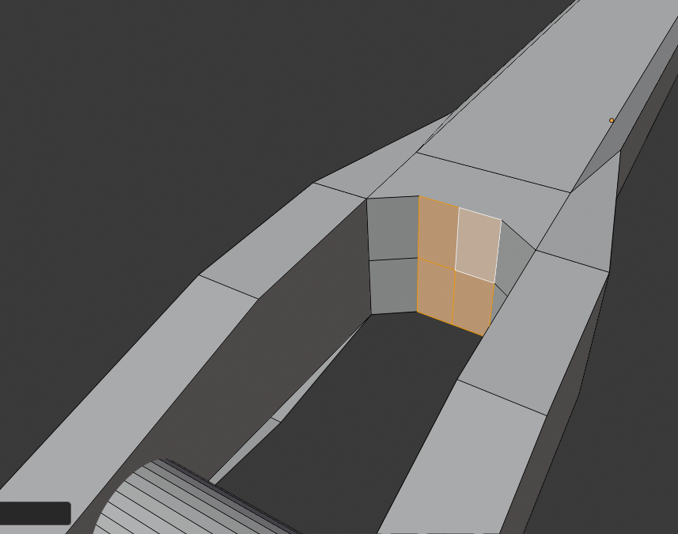

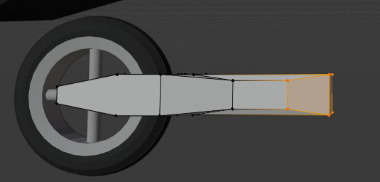

Now position the piston and wheel to fit to the body of the plane

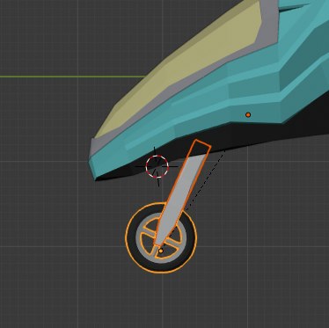

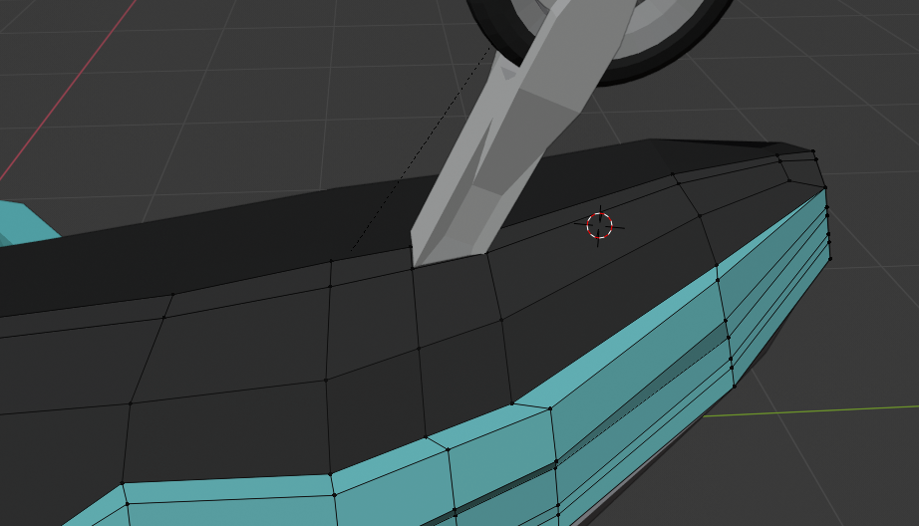

Add some loops to the underside, make sure to fit them close to the join section of the piston

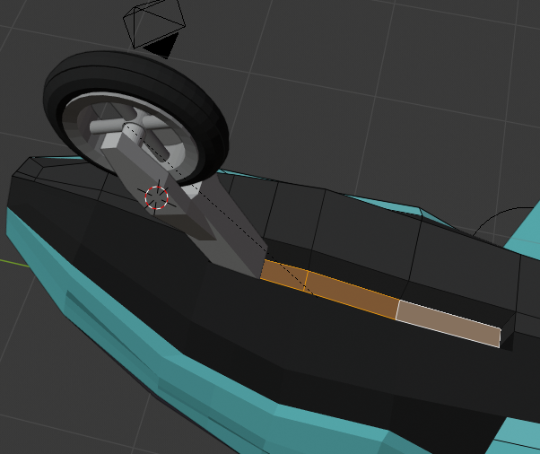

Now click back to the piston and wheel and create a cylinder and scale it down so it fits into the gap. It will be the mechanism that moves our piston

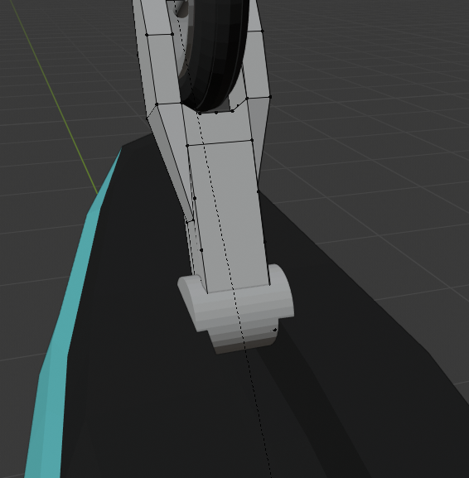

Add empty arrows to the centre of the cylinder and make it a child of the cylinder

Next move cursor to the empty location and set the origin of the wheel and piston to the empty location. Now add a limit rotation constraint to the piston. And set the x rotation min to 0 and max to 180. Ensure that local transform is used. Next add a limit distance constraint. This will limit the piston from moving anywhere and make animation easier.

Next up switch to objecg mode and duplicate the piston you made earlier, you will need to remove the constrainst from the new piston. Name it rear piston and add a mirror modifier to it. Then set the mirror object to the main body of the plane

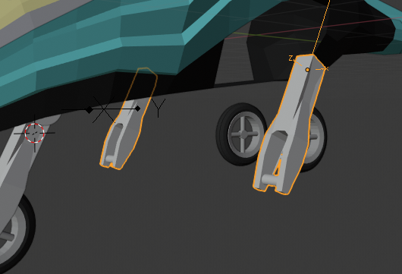

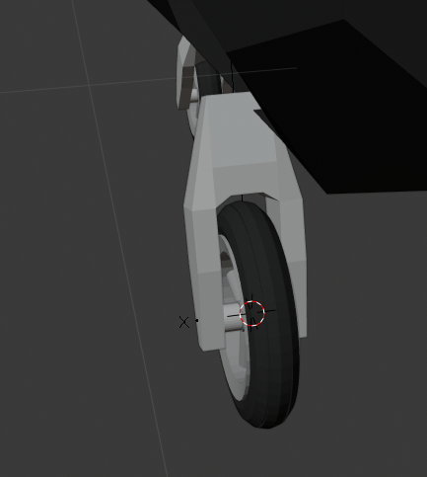 delete the faces of the shaft of the piston and align the piston to the wheel

Create a cylinder with 0.05 radius and 1 depth this will be the shaft

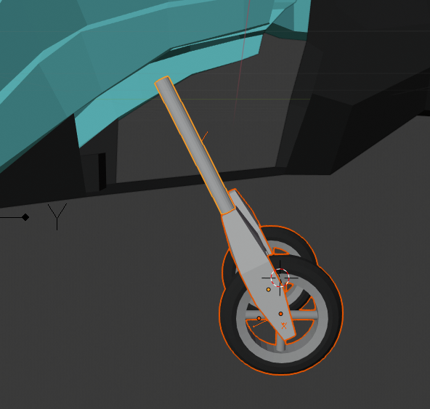

Add another cylinder and give it a 0.2 radius and a depth of 0.2

And position it ad the end of the pioston

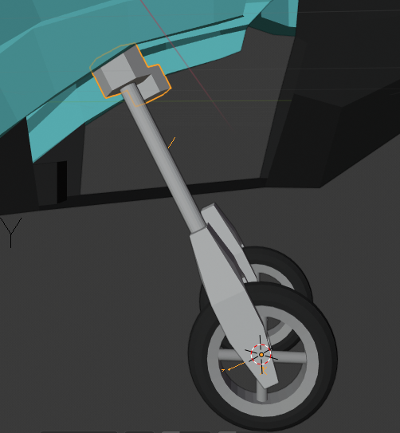

And an empty at the new cylinder and add a track to constraint to the wheel and connecting piston. Set the up axis to be y and the facing to be -y

Next up we’re going to fill up the empty space with new faces

Switch to edit mode on the main body extrude the edges the fill the empty space then merge the vertices with the body panel and the bottom of the plane

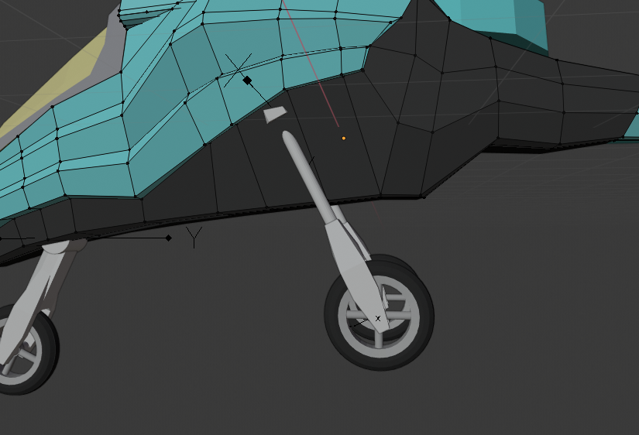 now we are going to create a loop along the body and use the new vertices to push the body of the plane inwards to make space for the pistons. Make sure to push only on the x axis.

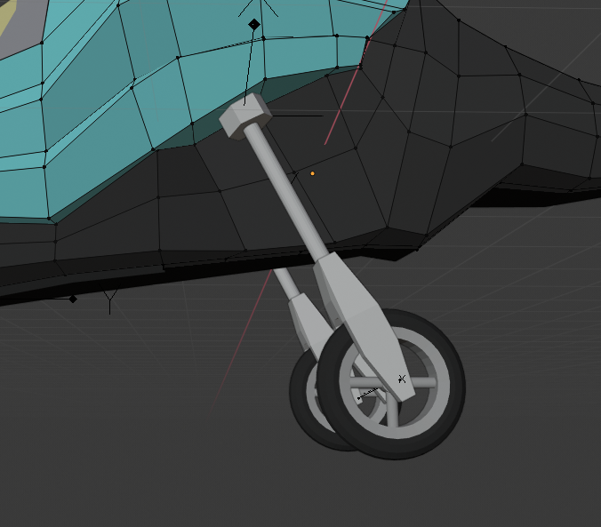

NEXT UP is making the wings a little nicer

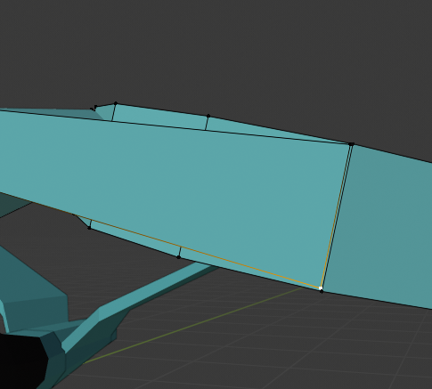 adjust the wings to make sure they are the same width as the gryo

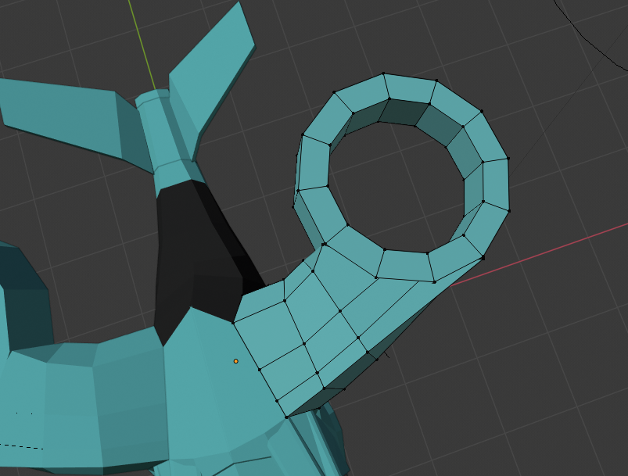

Now merge the newly made vertices of the wing to the vertices of the gryo

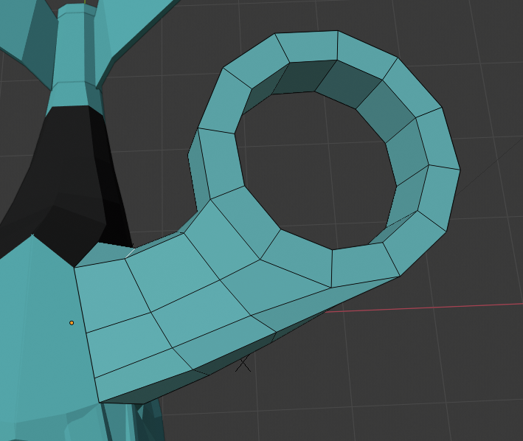

Additionaly I used edge slide to align some of my edges as they were misaligned causing an odd shape

Next add two edge loops around the whole wing

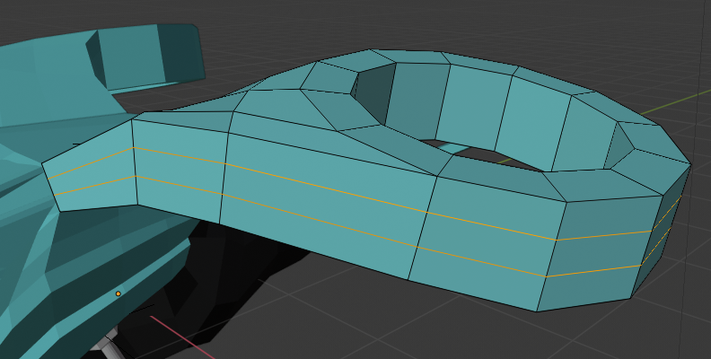

Select all the faces and scale it oout along the normal to create a more rounded look

Select the top circle vertices of the gyro and scale them in

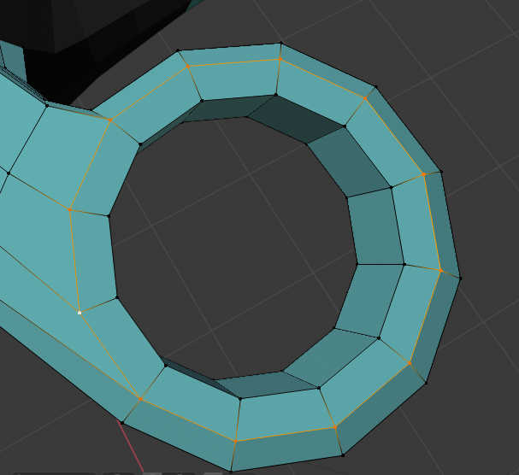do the same for the bottom

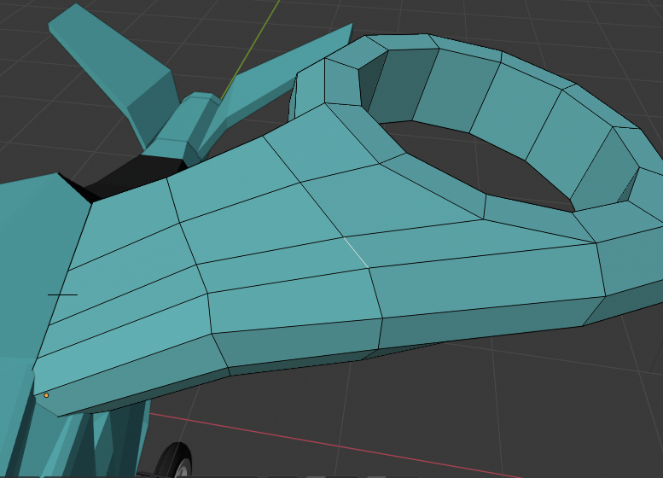 you can see my lines going across are not straight so lets straiten them out by using edge select and rotating them or using edge slide to align them. Ensure the shape of the wing is kept intact.

Add two edge loops

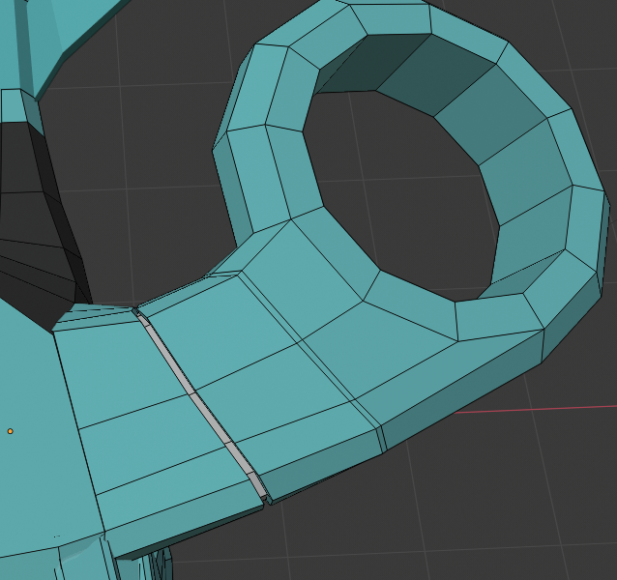

Then select the inside faces and extrude. Then scale them in a small amount

Next change the colour to dark grey for the wing joining part. Do this twice as shown above

Afterwards select the edge and bevel it using ctrl B

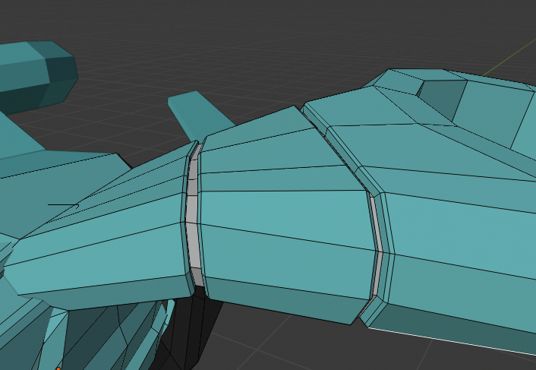

Next up we are going to create the fan that will be in side the gyro.

Firstly we will create a hub cap of sorts in the middle. To do this select the a circle of vertices of the gyro and dupoicate then scale it down so it will be in the centre of the gyro

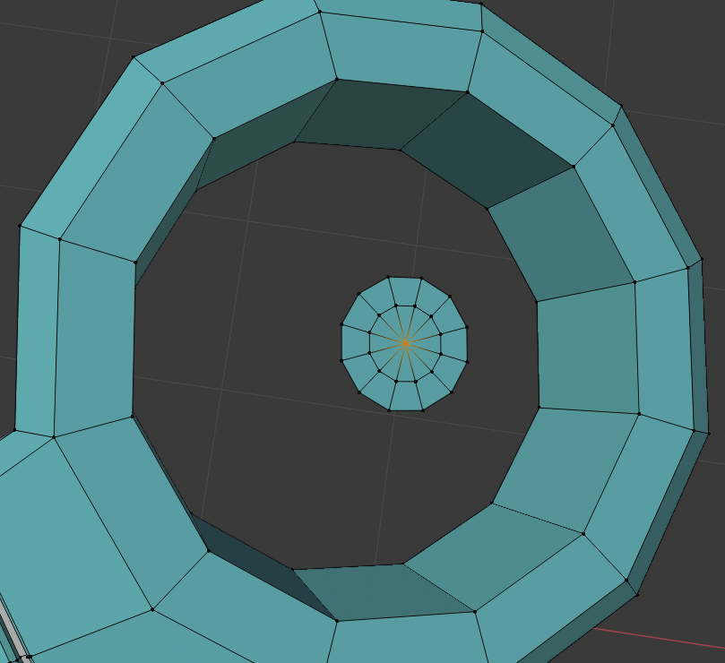

Extrude and scale again then merge at centre

now select the middle faces and switch to front view. Extrude upwards alongs the normal and scale inwards. Do this multiple times and merge at centre to finish the dome shape

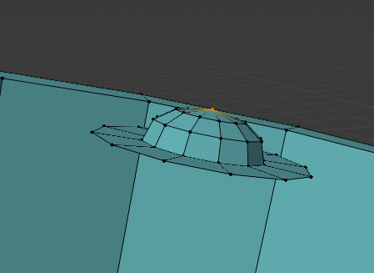

Now select the outer ring of vertices and extrude then plull down along the normal, to make this easier use the transform tools by present t and clicking move or transform. Then use the arrows and pull it down. Make sure transform orientation is set to normal for this 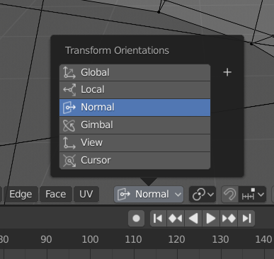

You need to extrude then tranlte downwards along the normal then extrude again and scale inwards

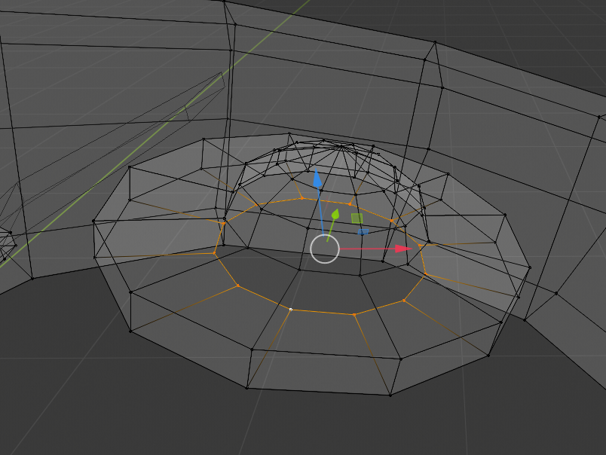

Next extrude again and translate downwards until the bottom of the gyro. then repeat the steps before to create the hubcap on the bottom side.

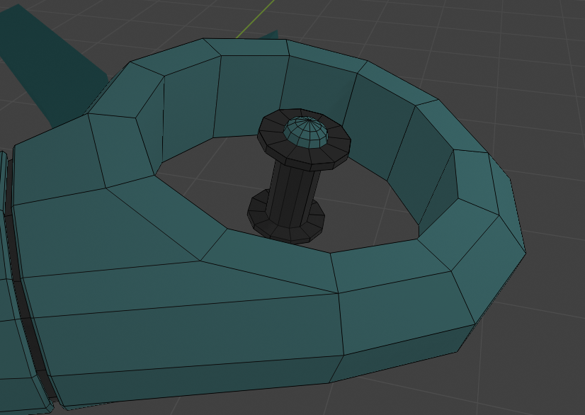 also change the colouirs to the image above. Next up is to create the blades of the propeller

Now set the selector to the middle of the hubcap column and create a new cube

Scale it down so it fits within the hubcap column. Then scale it out length wise. Additionaly add two loop cuts along the inside and scale it outwards to make more space for the properllor blade

